GILE Journal of Skills Development

The Title of the Article (Times New Roman, Bold, 18 pts)

Leave this do not remove (Author’s name will appear here) (Times New Roman, 16 pts, Bold)
Leave this do not remove (affiliation, including country/region)
- ORC ID: Leave this do not remove

Leave this do not remove (Co-Author’s name will appear here)
Leave this do not remove (affiliation, including country/region)
- ORC ID: Leave this do not remove

Abstract
Times New Roman, 12 pt. normal. Spacing: before 0, after 8, line spacing Multiple: 1.1. A single paragraph of a maximum of 250 to 300 words. For research articles, abstracts should give a pertinent overview of the work. We strongly encourage authors to include the following style of structured abstracts, without headings; Background: Place the question addressed in a broad context and highlight the purpose of the study; Methods: Briefly describe the main methods and data analyses; Results: Summarize the article's main findings; Conclusions: Indicate the main conclusions or interpretations; and Implications for the field: management or policy recommendations. The abstract should objectively represent the article; it must not contain results not presented and substantiated in the main text and should not exaggerate the main conclusions.
Keywords/key phrases: min. 3 keywords, max. 6
- Introduction
The introduction should briefly place the study in a broad context and highlight its importance. It should define the purpose of the work and its significance. The current state of the research field should be reviewed carefully, and key publications cited. Please highlight controversial and diverging hypotheses when necessary. Mention the main aim of the work. As far as possible, please keep the introduction comprehensible to generalist readers and scientists from outside your particular research field.
Times New Roman, 12 pt. normal. Spacing: before 0, after 8, line spacing Multiple: 1.1.
text text text text text text text text text text text text text text text text text text text text text text text text text text text text text text text text text text text text
text text text text text text text text text text text text text text text text text text text text text text text text text text text text text text text text text text text text text text
- numbered list text text text text text text text text text text text text text text text text text text text text text text text text text text text text text text text text text text text text
- text text text text text text text text text text text text text text text text text text text text text text text text text text text text text text text text text text text text text text
- text text text text text text text text text text text text text text text text text text text text text text text text text text text text text text text text text text text text text text
text text text text text text text text text text text text text text text text text text text text text text text text.
- Section Title (Times New Roman, 13 pt. bold. Spacing: before 6, after 8, line spacing Single)
All headings need to be numbered; use maximum three levels of headings, e.g., 1., 1.1., 1.1.1. Note that if a 1.1 is used, there must be at least a 1.2. The body of the text should be divided into meaningful main sections with individual headings to disclose the essence of the section. The sections can be subdivided into sub-sections.
  - Section Subtitle (Times New Roman, 12 pt. bold. Spacing: before 0, after 12, line spacing: single)
The body of the text should provide a concise and precise description of the methods, results, as well as their interpretation. The results and the findings should be discussed in the broadest context possible. Future research directions and practical/policy implications should also be highlighted.
Please note that important words can be emphasised by using bold (not underlining).
Body text text text text text text text text text text text text text text text text text text text text text text text text text text text text text text text text text text text text
- bulleted list. text text text text text text text text text text text text text text text text text text text text text text text text text text text text text text text text text text
- bulleted list. text text text text text text text text text text text text text text text text text text text text text text text text text text text text text text text text text text
Table 1. table caption
Table head | Table Column Head
copy | more table copy
copy | more table copy
Source: own compilation/calculations, based on Ref., Year, p. X
All illustrations, figures and tables are numbered and are placed within the text at the appropriate points. High-resolution figures (images, diagrams or graphs) can be uploaded as separate files during the submission process to ensure quality integrity. All figures and tables should be cited in the main text as Figure 1, Table 1, etc.
Figure 1. Figure caption

Source: Reference, Year
2.3.1. Chapter sub-sub title (Times New Roman, Font size: 12pt. Italicised)
text text text text text text text text text text text text text text text text text text text text text text text text text text text text text text text text text text.
2.3.2. How to use the Styles in the Article Template
Please refer to Figure 2. for the specific styles used in GJSD. These styles include the formatting for author names, body text, figure captions, and more. It is important to adhere to these styles when formatting your paper. Please make sure to follow all provided formatting instructions carefully.
Make sure you use the different Styles as indicated in this template. Styles are pre-defined formatting options within Microsoft Word that allow you to easily apply consistent formatting throughout your document. Specific styles are designated for different elements like headings, body text, references, and more. We pre-set the styles for you, please do not use any other Styles (see Figure 2.).
Look for the "Styles" pane on the right-hand side of your Word document. If you don't see it, you can activate it by clicking on the small arrow in the bottom right corner of the "Paragraph" section on the Home tab. This will expand the Styles pane (see Fig. 2). You'll see a list of styles available in this document. These include "Chapter title GJSD," "Declaration statement GJSD," "Body Text," "Figure Caption GJSD," "Reference," and others. Highlight the text you want to format, then click on the desired style in the Styles pane. Once you've applied a style to a particular type of text (e.g., "Heading 1" for all main titles), Word will automatically format any subsequent text you add using the same style. This helps ensure consistency throughout your manuscript. Stick with the pre-set styles provided by the journal for consistency.
Figure 2. Using GJSD Styles
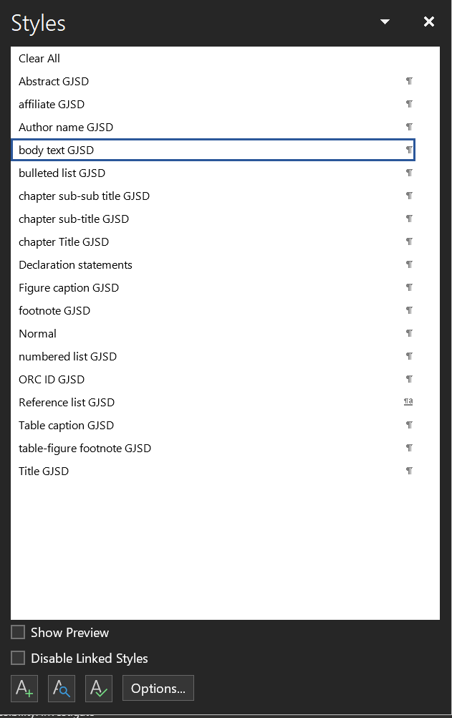
Source: Reference, Year
- Conclusion
Every paper should contain a Conclusions chapter, a brief summary of the study’s main aim, results and practical implications to recontextualise the research for the reader.
The implication section can include a paragraph or two that asserts the practical or managerial implications and links it to the study findings. Practical implications are potential values of the study with practical outcomes or how practitioners or policymakers can benefit from your results. Always explain how your findings can help them and the broad impact on the relevant industries or on society.
The GJSD accepts papers that include reflexivity. Even if only briefly, the researcher should consider of their own positionality, potential biases, assumptions, and influence on the research process and findings. This demonstrates awareness of the researcher's background, experiences, beliefs, and values might shape the research process.
text text text text text text text text text text text text text text text text text text text text text text text text text text text text text text text text text text
text text text text text text text text text text text text text text text text text text text text text text text text text text text text text text text text text text. text text text text text text text text text text text text text text text text text text text text text text text text text text text text text text text text text text. text text text text text text text text text text text text text text text text text text text text text text text text text text text text text text text text text text.

References
[see this link for various literature formats and examples (use APA 7th edition), APA Style]
Books (Book/ebook references (apa.org))
Author, A. A. (Year of publication). Title of the Book. Location: Publisher.
Book chapters in a book (Chapter in an edited book/ebook references (apa.org))
Example:
Aron, L., Botella, M., & Lubart, T. (2019). Culinary arts: Talent and their development. In R. F. Subotnik, P. Olszewski-Kubilius, & F. C. Worrell (Eds.), The psychology of high performance: Developing human potential into domain-specific talent (pp. 345–359). American Psychological Association. https://doi.org/10.1037/0000120-016
- Parenthetical citations: (Aron et al., 2019; Dillard, 2020; Thestrup, 2010)
- Narrative citations: Aron et al. (2019), Dillard (2020), and Thestrup (2010)
Articles (Journal article references (apa.org))
Author, A. A. (Year of publication). Title of article. Title of periodical, volume number (issue number) pages. DOI number
Author, A. A. & Author B. B. (Year of publication). Title of article. Title of periodical, volume number (issue number) pages. DOI number
Author, A. A. (Date of publication). Title of article. Title of Periodical, volume number (issue number), pages. Retrieved month date, year, from Database name.
Author, A. A. (Date of publication). Title of article. Retrieved month date, year, from http://web address.

ALL OTHER FORMATS OF SOURCES Reference examples (apa.org) and here.

Declaration Statements
Conflict of Interest
The author reports no conflict of interest.
Funding
The author received no financial support for this article's research, authorship, and/or publication.
Ethics Statement
No dataset is associated with this article.

Open Access Agreement
This article is published under a CC BY 4.0 license. This license allows reusers to distribute, remix, adapt, and build upon the material in any medium or format, so long as attribution is given to the creator. The license allows for commercial use. For more information, please visit
https://creativecommons.org/licenses/by/4.0/

Corresponding Author
The corresponding author for this manuscript is [Full name of the corresponding author] who can be contacted by email via [e-mail address].

